EXPERIMENT NO 2
Sketch a Simple Prototype of a Bus Ticket Booking System using Figma Tool

Aim
To design a simple prototype of a Bus Ticket Booking System using the Figma tool, providing an interface for searching buses, selecting seats, and booking tickets.
Procedure
- Open Figma and create a new design file.
- Create a mobile screen frame using the Frame tool.
- Design the Home Page with the title “Bus Ticket Booking” and input fields for From, To, Date of Journey, and a Search Buses button.
- Create a Bus Selection Page displaying available buses, departure times, arrival times, ticket prices, and a Select Seats button.
- Design a Seat Selection Page with available and booked seats in different colours.
- Create a Booking Summary Page displaying passenger details, selected seats, journey date, and total fare.
- Add a Payment Page with payment options and a Confirm Booking button.
- Use the Prototype tab to connect the screens and simulate the booking flow.
- Preview the prototype using the Present button.

OUTPUT:
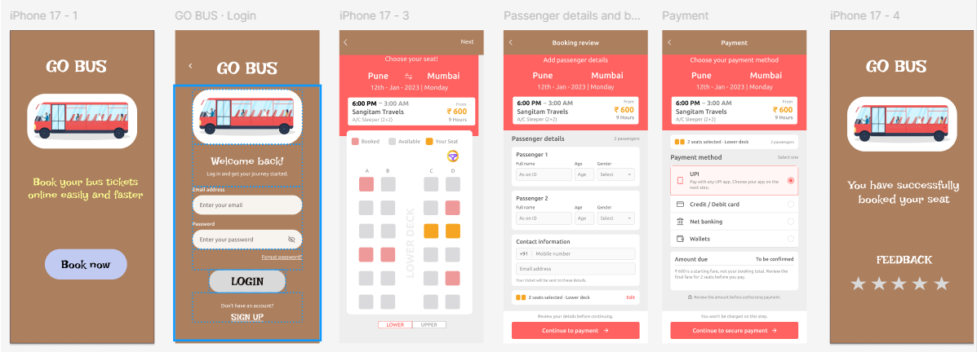
Result
A simple interactive prototype of the Bus Ticket Booking System was designed using Figma, allowing users to search for buses, select seats, view booking details, and proceed to payment.

